**Assignment 6**

**Problem Statement**

**Design and deploy a web application in a PaaS environment.**

**Aim: To design and deploy a web application in platform as a service (paas) environment**

**Theory:**

**As Google app is a platform as service environment, so here we are designing and deploying a web application using Google app engine.**

Platform as a Service (PaaS) provides a runtime environment. It allows programmers to easily create, test, run, and deploy web applications. You can purchase these applications from a cloud service provider on a pay-as-per use basis and access them using the Internet connection. In PaaS, back end scalability is managed by the cloud service provider, so end- users do not need to worry about managing the infrastructure.

PaaS includes infrastructure (servers, storage, and networking) and platform (middleware, development tools, database management systems, business intelligence, and more) to support the web application life cycle.

**Example:** Google App Engine, Force.com, Joyent, Azure.

**Google App Engine**

Google App Engine (often referred to as GAE or simply App Engine) is a [cloud computing](https://en.wikipedia.org/wiki/Cloud_computing) [platform as a service](https://en.wikipedia.org/wiki/Platform_as_a_service) for developing and hosting [web applications](https://en.wikipedia.org/wiki/Web_application) in Google-managed [data centres](https://en.wikipedia.org/wiki/Data_center). Applications are [sandboxed](https://en.wikipedia.org/wiki/Sandbox_(computer_security)) and run across multiple servers. App Engine offers automatic scaling for web applications—as the number of requests increases for an application, App Engine automatically allocates more resources for the web application to handle the additional demand.

Google App Engine primarily supports [Go](https://en.wikipedia.org/wiki/Go_(programming_language)), [PHP](https://en.wikipedia.org/wiki/PHP), [Java](https://en.wikipedia.org/wiki/Java_(programming_language)), [Python](https://en.wikipedia.org/wiki/Python_(programming_language)), [Node.js](https://en.wikipedia.org/wiki/Node.js), [.NET](https://en.wikipedia.org/wiki/.NET_Framework), and [Ruby](https://en.wikipedia.org/wiki/Ruby_(programming_language)) applications, although it can also support other languages via "custom runtimes". The service is free up to a certain level of consumed resources and only in standard environment but not in flexible environment. Fees are charged for additional storage, [bandwidth](https://en.wikipedia.org/wiki/Bandwidth_(computing)), or instance hours required by the application.

**Steps to install Google App Engine**

**1) Download Eclipse version 4.21**

**2) Download Google SDK**

**https://cloud.google.com/sdk/docs/quickstart**

**3) Download the Google Cloud CLI installer.**

**4) Launch the installer and follow the prompts. The installer is signed by Google LLC.**

**5) Cloud SDK requires java; supported versions are (4.8 to 4.11). To use Cloud SDK, your**

**Operating system must be able to run a supported version of eclipse.**

Installation Steps:

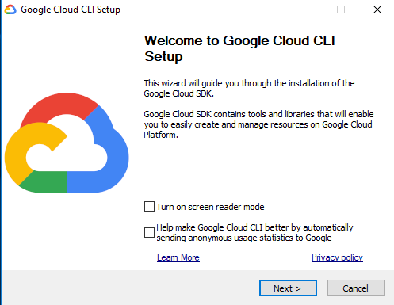

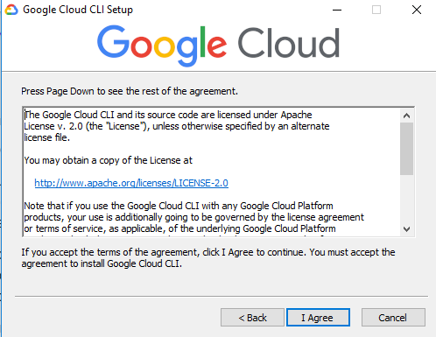

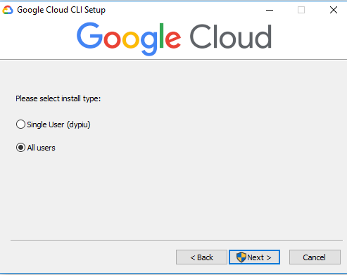

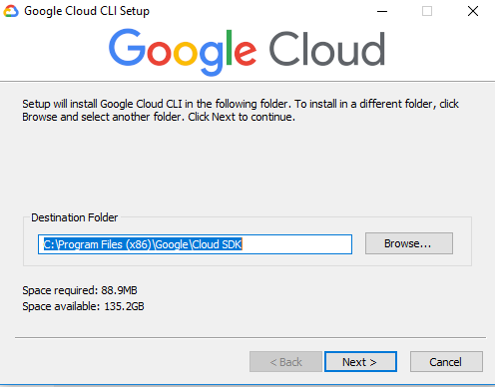

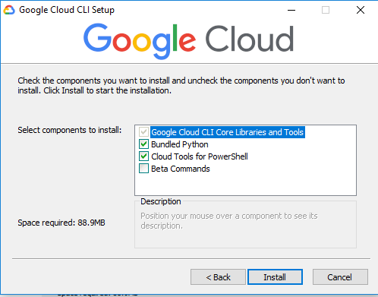

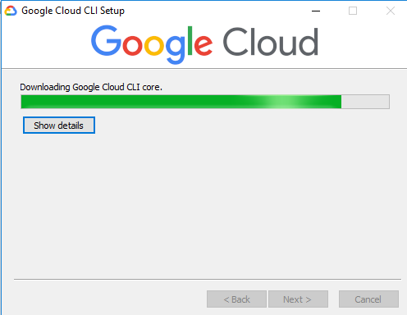

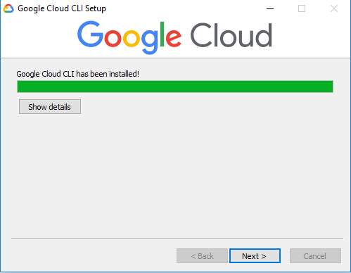

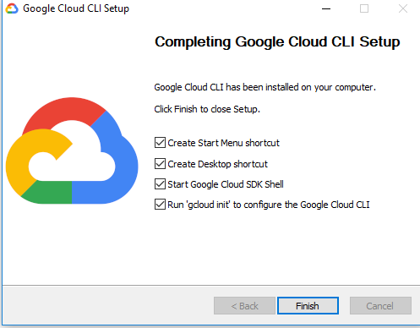

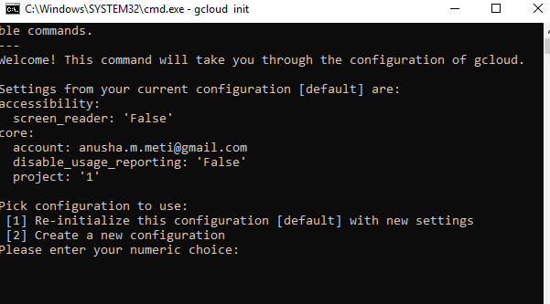

**For Esclipse**

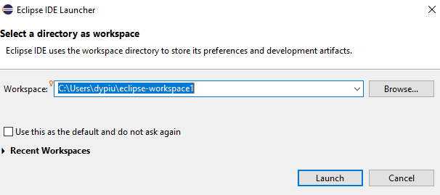

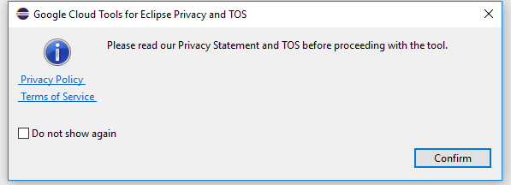

After the installation part host your own web application as we did for 1st assignment and attach the same screenshots